- DB Connections:
  - By default, the DataSource.groovy file lists dev, test and prod settings for the supplied H2 database. The problem with these defaults is that you can't use the nifty little h2 db console to view the data and perhaps muck with a bit of until you add AUTO_SERVER=TRUE to the jdbc URL like so:
    - url = "jdbc:h2:devDb;MVCC=TRUE;LOCK_TIMEOUT=10000;DB_CLOSE_ON_EXIT=FALSE;AUTO_SERVER=TRUE"
  - Here's some cygwin command line one liners to make your life easier:
    - Start the grails console:
      - grails console
    - Start the h2 DB console:
      - java -cp C:/Dev/Tools/Grails/2.4.0/grails-2.4.0/lib/com.h2database/h2/jars/h2-1.3.173.jar org.h2.tools.Server
      - then, select the generic data source and paste in the url from the DataSource.groovy

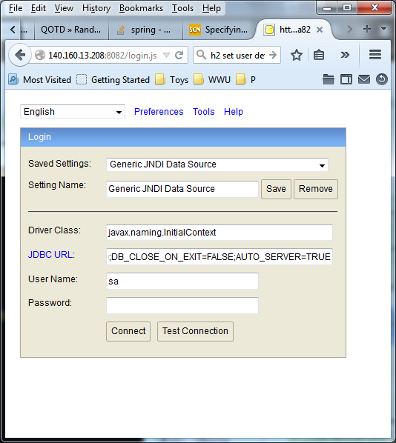

- Also, since you'll probably want to organize your data under a particular schema, you'll need to do the following:
- Login to the h2 console as an admin (as shown above)
- Create a schema via 'create schema appName'
- Modify you jdbc url in DataSource.groovy like so:
- Append 'INIT=set schema appName' to the jdbc URL, as in
url = "jdbc:h2:devDb;MVCC=TRUE;LOCK_TIMEOUT=10000;DB_CLOSE_ON_EXIT=FALSE;AUTO_SERVER=TRUE;INIT=set schema QOTD"
- Change the hibernate environment directive to “create-drop”
- Then run your app via grails run-app... this will create the table and add data if your app adds data, or you can add data via the grails console via commands like:
- new qotd.Quote(author: 'Larry Wall',
content: 'There is more than one method to our madness.').save()
- println qotd.Quote.count()
- Don't forget to change the dbCreate setting back to update after running the app once.

A complete DataSource.groovy might look like this:
This was taken from /cygdrive/c/Dev/Docs/eBooks/Grails-In-Action-2nd-Edition-Code/graina2-master/ch01/qotd-sandbox/qotd-sandbox
------------------------ DataSource.groovy ----------------------------------------------------
dataSource {
pooled = true
jmxExport = true
driverClassName = "org.h2.Driver"
username = "sa"
password = ""
}
hibernate {
cache.use_second_level_cache = true
cache.use_query_cache = false
// cache.region.factory_class = 'net.sf.ehcache.hibernate.EhCacheRegionFactory' // Hibernate 3
cache.region.factory_class = 'org.hibernate.cache.ehcache.EhCacheRegionFactory' // Hibernate 4
singleSession = true // configure OSIV singleSession mode
}

// environment specific settings
environments {
development {
dataSource {
dbCreate = "update" // one of 'create', 'create-drop', 'update', 'validate', ''
//url = "jdbc:h2:mem:devDb;MVCC=TRUE;LOCK_TIMEOUT=10000;DB_CLOSE_ON_EXIT=FALSE"
//url = "jdbc:h2:devDb;MVCC=TRUE;LOCK_TIMEOUT=10000;DB_CLOSE_ON_EXIT=FALSE"
//url = "jdbc:h2:devDb;MVCC=TRUE;LOCK_TIMEOUT=10000;DB_CLOSE_ON_EXIT=FALSE;AUTO_SERVER=TRUE"
url = "jdbc:h2:devDb;MVCC=TRUE;LOCK_TIMEOUT=10000;DB_CLOSE_ON_EXIT=FALSE;AUTO_SERVER=TRUE;INIT=set schema QOTD"
properties {
// See http://grails.org/doc/latest/guide/conf.html#dataSource for documentation
jmxEnabled = true
initialSize = 5
maxActive = 50
minIdle = 5
maxIdle = 25
maxWait = 10000
maxAge = 10 * 60000
timeBetweenEvictionRunsMillis = 5000
minEvictableIdleTimeMillis = 60000
validationQuery = "SELECT 1"
validationQueryTimeout = 3
validationInterval = 15000
testOnBorrow = true
testWhileIdle = true
testOnReturn = false
jdbcInterceptors = "ConnectionState"
defaultTransactionIsolation = java.sql.Connection.TRANSACTION_READ_COMMITTED
}

}
}
test {
dataSource {
dbCreate = "update"
url = "jdbc:h2:mem:testDb;MVCC=TRUE;LOCK_TIMEOUT=10000;DB_CLOSE_ON_EXIT=FALSE"
}
}
production {
dataSource {
dbCreate = "update"
url = "jdbc:h2:prodDb;MVCC=TRUE;LOCK_TIMEOUT=10000;DB_CLOSE_ON_EXIT=FALSE"
properties {
// See http://grails.org/doc/latest/guide/conf.html#dataSource for documentation
jmxEnabled = true
initialSize = 5
maxActive = 50
minIdle = 5
maxIdle = 25
maxWait = 10000
maxAge = 10 * 60000
timeBetweenEvictionRunsMillis = 5000
minEvictableIdleTimeMillis = 60000
validationQuery = "SELECT 1"
validationQueryTimeout = 3
validationInterval = 15000
testOnBorrow = true
testWhileIdle = true
testOnReturn = false
jdbcInterceptors = "ConnectionState"
defaultTransactionIsolation = java.sql.Connection.TRANSACTION_READ_COMMITTED
}
}
}
}

- Setting error messages in bundles:
To make the messages more relevant, create an entry in messages.properties
specifically for them:
profile.homepage.url.invalid=You must provide a valid web address for your
homepage. [{2}] simply does not cut it.
profile.email.email.invalid=You must provide a valid email address. [{2}] is
just not the business.
That’s all you have to do—Grails automatically selects these messages for your profile
fields based on conventions. To leverage those conventions, use message keys (the text
to the left of the =) of the form shown in figure 4.3.
That was easy, but how did we know that the invalid value substitutes the parameter {2}
in the message text? It can be inferred from the default validation messages, but it isn’t
documented in the Grails user guide. That isn’t particularly helpful for people learning
the framework, so here are the parameter numbers and what those parameters contain:
■ {0}—The name of the domain class property.
■ {1}—The name of the domain class.
■ {2}—The invalid value.
■ {3}—The limiting value in the constraint, such as a maximum value or a matching
pattern. Applies to match, max, min, maxSize, minSize, inList, and equals
constraints.
■ {4}—The upper bound for a constraint ({3} is the lower bound). Applies to
range and size constraints.

- Generating Angular.js in your scaffolding:
  - A Grails plugin for scaffolding views using Angular.js, https://github.com/robfletcher/grails-angular-scaffolding.

- BootStrap.groovy:
  - Execution order:
You have no guarantees when the code in the environments block will be executed
relative to other code in BootStrap. It seems that, at present, the block is executed
after everything else in the init closure. But that may change in the future as this behavior isn’t documented anywhere.

- Activating environments:
  - One ugly spot in Grails that can confuse newcomers is an inconsistency in how you
activate environments and reference them within your code. The previous example
even showed two different ways to test the current environment! To help you get a
handle on environments, we’ve listed their different forms in table 5.1.

Table 5.1 The different faces of environments
Name Constant Command line activation
development Environment.DEVELOPMENT grails dev . . .
test Environment.TEST grails test . . .
production Environment.PRODUCTION grails prod . . .

<user-defined>, for
example, myEnv
Environment.CUSTOM grails -Dgrails.env=myEnv . .

GORM Gotchas:
- Don't name any domain class members 'property', as in the bbr Image domain class. The Property domain class has a one to many to Image so you need to include a Property member in Image. But if you call that Property member 'property' in the class def, as in Image.property then you're screwed. Turns out 'property' is a reserved word or some such. See StackOverflow ditty:
https://stackoverflow.com/questions/20214511/grails-error-saving-object-hard-to-understand-dont-use-property-keyword/20220010#20220010
This manifested itself when I tried to run an integration test that called validate() on an Image object. The stack traces was:
---------------------------------------------------------------------------------------------------------------
.
|Running 2 integration tests... 1 of 2
|Running 2 integration tests... 2 of 2
|Running 2 integration tests... 3 of 3
Failure: |
saving an image without a property_id(net.bbr.model.domain.test.integration.ImageIntegrationSpec)
|
java.lang.ArrayIndexOutOfBoundsException: 0
at net.bbr.model.domain.test.integration.ImageIntegrationSpec.saving an image without a property_id(ImageIntegrationSpec.groovy:71)
|Completed 3 integration tests, 1 failed in 0m 3s
.Tests FAILED
|
- view reports in C:\Dev\Projects\Juno\grails\237\bbr\target\test-reports
Error |
Forked Grails VM exited with error
---------------------------------------------------------------------------------------------------------------

